Experiment 2

Extended Euclidean Algorithm:-
Code:-
#include <stdio.h>
int main()
{
int n1, n2, r, r1, r2, s, s1, s2, t, t1, t2, q, temp, sum1, sum2;
printf("Enter 2 Numbers:-\n");
scanf("%d %d",&r1, &r2);
n1=r1;
n2=r2;
if(r1<=r2)
{
temp=r1;
r1=r2;
r2=temp;
}
s1=1;
s2=0;
t1=0;
t2=1;
printf("q\tr1\tr2\tr\ts1\ts2\ts\tt1\tt2\tt\n");
while(r2!=0)
{
q=r1/r2;
r=r1%r2;
s=s1-q*s2;
t=t1-q*t2;
printf("%d\t%d\t%d\t%d\t%d\t%d\t%d\t%d\t%d\t%d\n",q,r1,r2,r,s1,s2,s,t1,t2,t);
r1=r2;
r2=r;
s1=s2;
s2=s;
t1=t2;
t2=t;
}
sum1=s1*n1;
sum2=t1*n2;
printf("\nGCD : %d\ns : %d\nt : %d\n",r1,s1,t1);
printf("s*a + t*b = gcd(a, b)\n%d*%d + %d*%d = %d",s1,n1,t1,n2,r1);
printf("\n%d + %d = %d",sum1,sum2,r1);
return 0;
}

Output:-

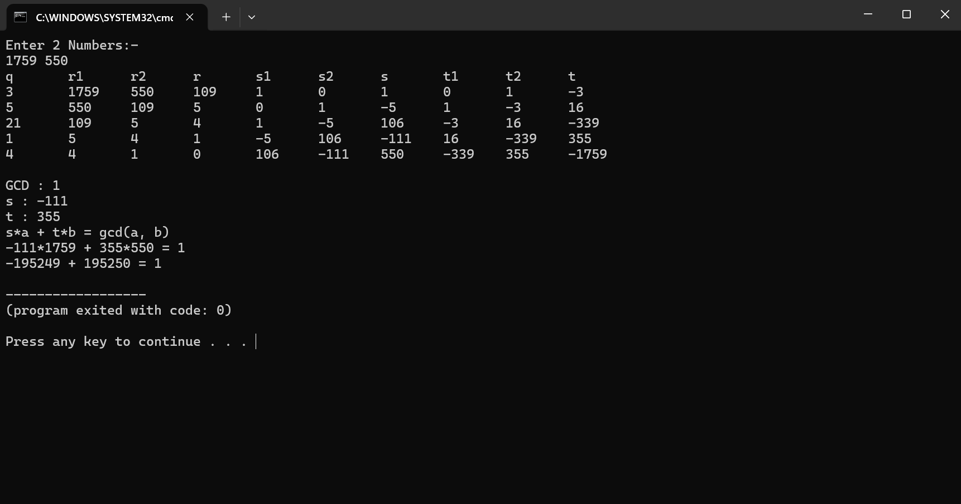
Euler’s Totient Function:-
Code:-
#include <stdio.h>
#include <stdbool.h>

bool isPrime(int n);
bool isGCD1(int a, int b);

int main()
{
int i, n, fact[100], j=0, RelPrime[100], k=0;
printf("Enter the number : ");
scanf("%d",&n);
if(isPrime(n))
{
printf("%d is a Prime Number\n",n);
printf("Relatively Prime Numbers are : [ ");
for(i=1;i<n;i++)
printf("%d ",i);
printf("]\nphi(%d) = %d",n,n-1);
}
else
{
printf("%d is not a Prime Number\n",n);
for(i=1;i<=n;i++)
{
if(n%i==0)
{
fact[j]=i;
j++;
}
}
printf("Factors of %d are : [ ",n);
for(i=0;i<j;i++)
printf("%d ",fact[i]);
printf("]\nPrime Factors are : [ ");
for(i=1;i<j;i++)
{
if(isPrime(fact[i]))
printf("%d ",fact[i]);
}
printf("]\nRelatively Primes are : [ ");
for(i=1;i<n;i++)
{
if(isGCD1(n, i))
{
RelPrime[k]=i;
printf("%d ",RelPrime[k]);
k++;
}
}
printf("]\nphi(%d) = %d",n,k);
}
return 0;
}

bool isPrime(int n)
{
int i;
for(i=n-1;i>1;i--)
{
if(n%i==0)
return false;
}
return true;
}

bool isGCD1(int a, int b)
{
int i;
for(i=2;i<=b;i++)
{
if(a%i==0 && b%i==0)
return false;
}
return true;
}
Output:-
